Cloud Computing Assignment
TASK 1

Question 1: Create a Free AWS/Azure Account and Log In
I created a free AWS account and logged in to the AWS Management Console. After logging in, I accessed the dashboard where all cloud services are available. The dashboard displays my account information, available services, billing options, and the search bar for finding AWS services.
Screenshot:
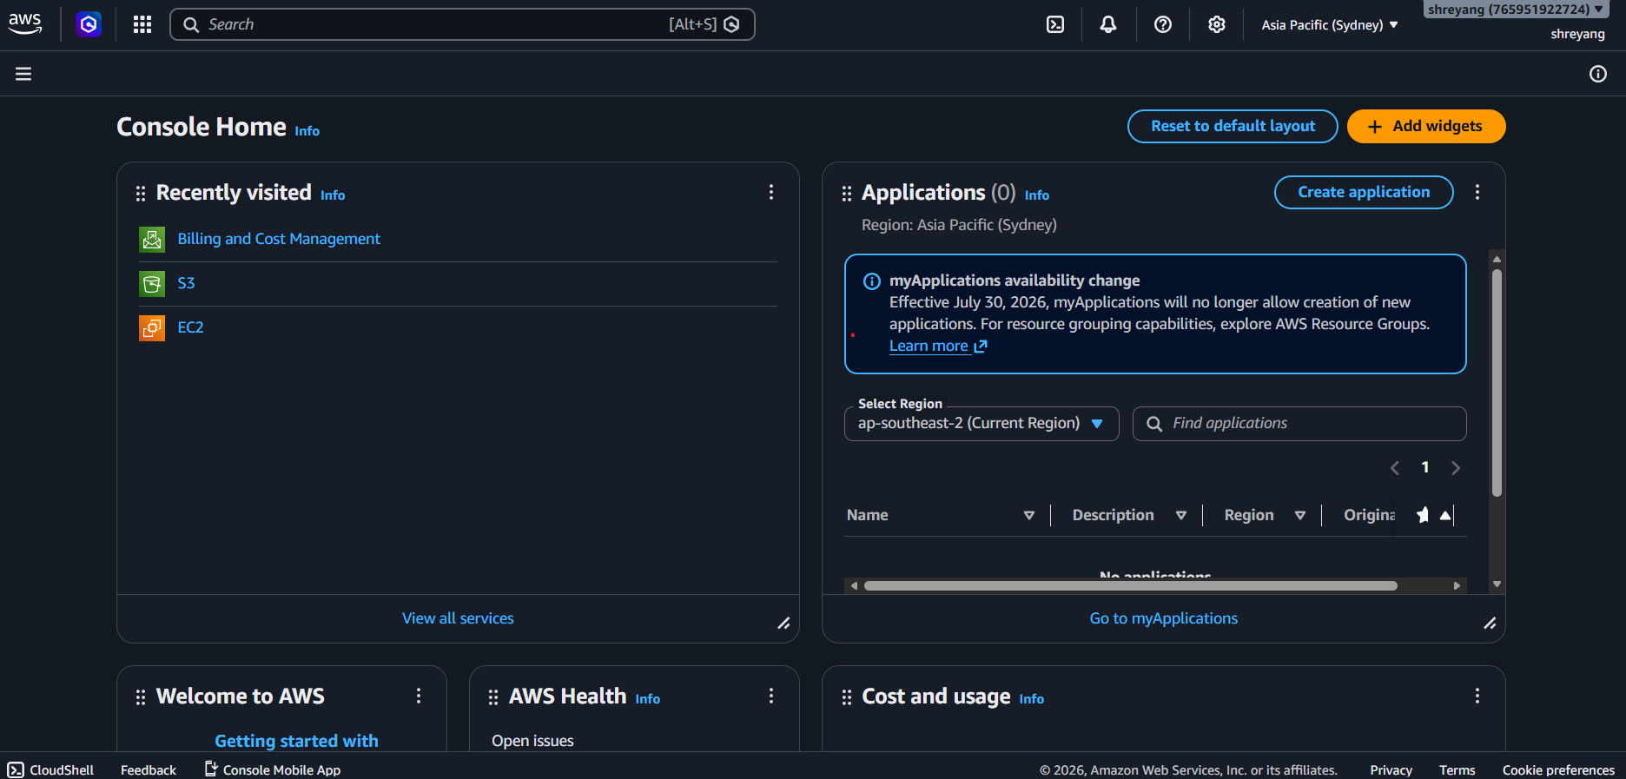

Question 2: Five Key AWS Services
Service | Purpose | Example of Real Application
Amazon EC2 (Compute) | Provides virtual servers to run applications and websites. | Instagram uses compute servers to process user requests and run its application.
Amazon S3 (Storage) | Stores files, images, videos, backups, and other data securely. | Flipkart stores product images and customer files.
Amazon RDS (Database) | Manages relational databases without requiring manual maintenance. | Zomato stores restaurant details, customer information, and orders.
Amazon VPC (Networking) | Creates a secure private network for AWS resources. | Paytm uses secure networking to protect financial transactions.
Amazon CloudWatch (Monitoring & Analytics) | Monitors application performance, server health, and system logs. | Netflix monitors its streaming servers to detect and resolve issues quickly.

Question 3: Finding Amazon S3 and Its Use
Steps to Locate Amazon S3
- Log in to the AWS Management Console.
- Locate the search bar at the top of the dashboard.
- Type S3 into the search bar.
- Select Amazon S3 from the search results.
- The Amazon S3 dashboard opens, where buckets can be created and managed.
How Spotify Could Use Amazon S3
Spotify can use Amazon S3 to store music files, album artwork, podcasts, and other media securely. Amazon S3 offers highly durable and scalable storage, allowing Spotify to store millions of files while ensuring fast access for users around the world.

Question 4: Cloud Computing Characteristic
Rapid Elasticity
Rapid elasticity means cloud resources can automatically increase or decrease depending on the number of users. During busy periods, additional resources are provided automatically, and when traffic decreases, the extra resources are released.
A good example is BookMyShow. When tickets for a popular movie or concert become available, thousands of users visit the app at the same time. Cloud computing automatically increases the number of servers to handle the heavy traffic, ensuring that the app continues to work smoothly. Once the rush is over, the extra servers are removed, which helps reduce costs while maintaining good performance.

Conclusion
Cloud computing provides businesses with reliable, secure, and scalable IT resources without requiring expensive physical infrastructure. Services such as Amazon EC2, Amazon S3, Amazon RDS, Amazon VPC, and Amazon CloudWatch enable organizations to build applications that are efficient, highly available, and capable of handling millions of users across the world.

